Florence County School District Three
125 South Blanding Street, Lake City, SC 29560

Parent & Community Involvement Plan

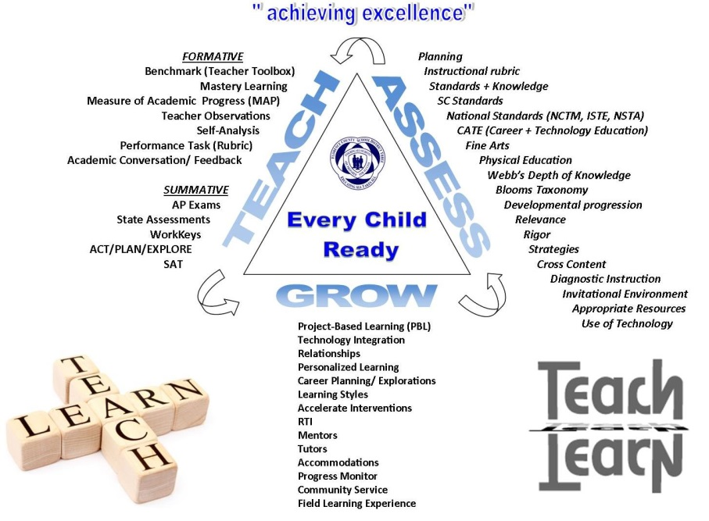

2015 -2016
Table of Contents

Mission Statement……………………………..…………………………3
Parent Involvement Goals……………………..…………………………3
District Administration & Board of Trustees.......................................…...4
District Parent & Community Involvement Committee……….….……..5
District Parent & Community Involvement Philosophy.....................…...6-8
Parent Survey…………………………………………………….……....9-12
How Parents Can Get Involved/Suggestions............….…………………13

Florence County School District Three

Mission, Vision, Beliefs/Values, Goals

Mission: The mission of Florence School District Three is to ensure our students are college and/or career ready.

Vision: Excellence and lifelong learning for all

Beliefs/Values:
- To inspire success for all
- To discover and maximize the potential of all
- To make decisions based on what’s best for children
- Educating All Takes All

Goals
- To ensure the safety of all district schools, offices, students, and staff. (Strategic Plan Goal # 4).
- To improve the academic success of all students. (Strategic Plan Goal # 1, 4, 5)
- To increase the number of students reading on grade level in grades K-3rd. (Strategic Plan Goal # 1, 5)
- To recruit, retain, and train excellent instructional and administrative staff. (Strategic Plan Goal # 2)
- To build effective school, community, and business relationships/partnerships. (Strategic Plan Goal # 3, 4)
- To ensure financial stability. (Strategic Plan Goal # 1, 4)

Florence County School District Three

Superintendent
Laura Hickson, EDS

Principals
Lake City Early Childhood Center……………..…….Mary Howard
Main Street Elementary........................................…...Shemmicca Moore
J. C. Lynch Elementary……………….……….……..Matthew Scandrol
Scranton Elementary……………………….…….…..Allana Prosser
Olanta Elementary………………………….…..…….Katherene Tisdale
J. Paul Truluck Intermediate........................................Jeanette Altman
Ronald E. McNair Jr. High...................................…...Margie Myers
Lake City High…………………………………….….Ned Blake

Board of Trustees
Dr. Lane N. Floyd, Chairman
Barbara Singletary-Bryant, Vice-Chairperson
Paula Morris, Secretary
Toby Ackerman
Michael D. Blakeley
Terrie Gaskins-Bryant
John L. Graham
Debra McKnight
Dr. Julia G. Mims

Florence County School District Three
Parent & Community Involvement District Committee
2015 – 2016

Barbara Woodbury – District Office – Title I Administrator
Linda Hair – District Office – Title I Coordinator
Penny Moore – District Office – Classified Representative
Paula Morris – Board of Trustees – Board of Trustee Secretary
Eleta McCray – Lake City Early Childhood Center – Parent Liaison
Dianne McKenzie – Olanta Elementary – Parent Liaison
Jerry State – Main Street Elementary – Parent Liaison
Sharon Hammond – Scranton Elementary – Parent Liaison
Marie Coker – Scranton Elementary – Parent Representative
Joseph Woodbury – J. Paul Truluck Intermediate School – Tech Coach
Dianne Haines – Ronald E. McNair Jr. High – Parent Liaison
Susie Blaine – Ronald E. McNair Jr. High – Staff Representative
Joyce Gamble-Brown – Lake City High School – Parent Liaison
Anna Washington - Lake City High School – Parent Representative
Lenora Caldwell – Lifelong Learning Center – Parent Liaison
Ruth Frierson – Business/Community Member
Vivian Hailes – Community Member
Florence County School District Three
Parent & Community Involvement Plan Philosophy

Florence County School District Three (FCSD3) recognizes that a child’s education is a responsibility shared by the school and family during the entire time the child spends in school. To support the goal of the schools to educate all students effectively, the schools and parents must work as knowledgeable partners. Parents are an integral component of a school’s ability to provide for the educational success of their children. The school endeavors to meet the diverse cultural and language needs of parents and children. FCSD3 acknowledges that schools should foster and support active parental involvement.
In response to this commitment to active parental and community involvement and in compliance with the legal requirements of the South Carolina Education Accountability Act; the South Carolina Parental Involvement in Their Children’s Education Act; the Elementary and Secondary Education Act, re-authorized as the No Child Left Behind Act of 2002, Title I; and the Individuals with Disabilities Education Act; Florence County School District Three has developed this Parent & Community Involvement Plan.
This Plan, established in collaboration with parents, businesses and community members, includes programs and practices that enhance opportunities for parental involvement and reflects the specific needs of students and their families at each school.
The Parent & Community Involvement Plan involves parents of students of all grade levels in a variety of roles. The Plan recognizes that communication between home and school should be regular, two-way, and meaningful. To encourage this communication, the district has identified strategies and activities that are appropriate for the age and grade level of each student.
To encourage communication with parents, at least one parent-teacher conference per semester is scheduled on each campus in the district.
To promote and support responsible parenting, each school in the district has a Parent Center. Each school will purchase books, magazines and other informative materials regarding responsible parenting through the school libraries, the Parent Center, and Title I, if applicable. These materials will be advertised through the school’s newsletters, the school’s website, and the Student Handbooks, and parents will have an opportunity to check out the materials for study and/or review.
An “Open House” meeting will be scheduled annually on each campus. Topics that could be covered include:
- The state of the school.
- What students will be learning.
- How students will be assessed.
- What parents should expect for their child’s education.
- How parents can assist and make a difference in their child’s education.

Each school will publish a volunteer resource pamphlet listing the interests and availability of volunteers. The pamphlet will help match school needs with volunteer interests. To develop the volunteer pamphlet, the school will:
- Survey parents regarding their interests, so that volunteer work will be meaningful;
- Determine how frequently a volunteer would like to participate, including just one time a year;
- Include options for those who are available to help at home; and,
- Provide the parent/volunteer application form for district approval.
As part of the District’s Parent & Community Involvement Plan, trifold pamphlets will be printed attesting to the school district’s commitment to parental involvement and will be distributed to parents of students as well as to community businesses.
The District will sponsor meetings to inform the parents of middle and high school students about how to be involved in the decisions affecting course selection, career planning, and preparation for post-secondary opportunities.
The District recognizes that community resources strengthen school programs, family practices, and student learning. To take advantage of these resources, parents from the schools will be contacted to form School Improvement Councils/School-wide Planning Committees. The Councils/Committees will provide advice and guidance for school improvement.
Florence County School District Three will support the development, implementation, and annual evaluation of the plan to involve parents in the decisions and practices of the school district, using to the degree possible, the following components:
- The principal of each school in the district will designate one staff member that is willing to serve as a parent facilitator to organize meaningful training for staff and parents promoting and encouraging a welcoming atmosphere that will foster parent involvement in the school.
- The parent facilitator will also undertake efforts to ensure that parent participation is recognized as an asset to the school.
- The District, through the Board of Trustees, will annually recognize those parents who volunteer services at the schools.
Staff development opportunities for faculty and staff, as required by the State Board of Education, will be offered each year. Professional development, at the school and/or district level, will be designed to enhance understanding of effective parent involvement strategies and to create a climate conducive to parental participation.
It is the goal of Florence County School District Three to assure an ongoing partnership between families, communities, and schools.

Please complete the following parent survey on-line at the link below:
https://www.surveymonkey.com/r/201516Title1
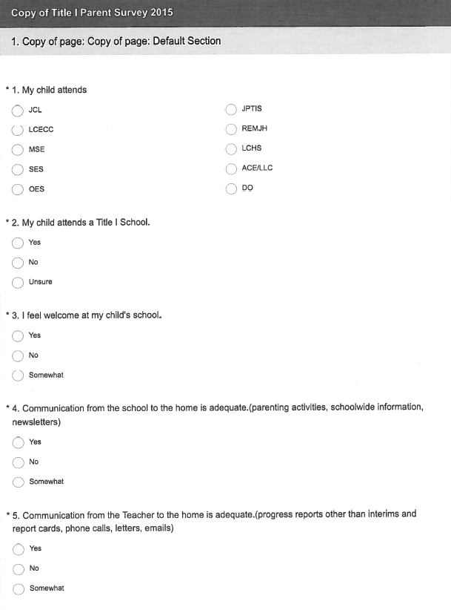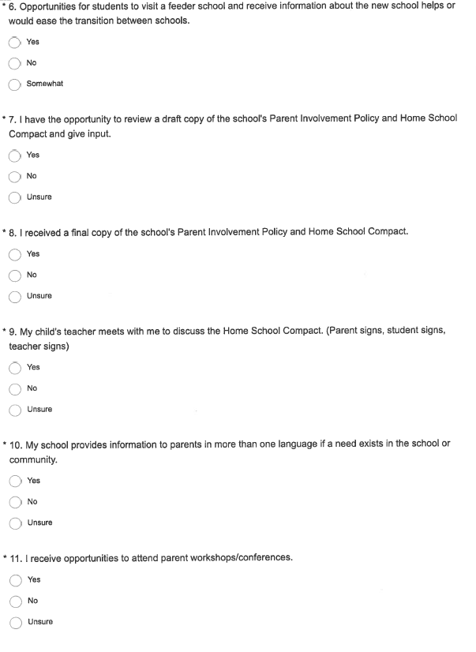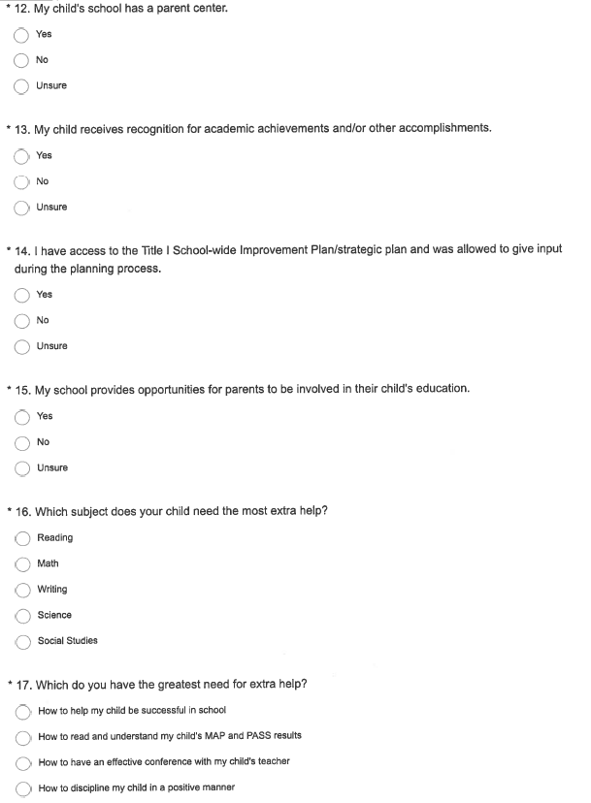 How Can Parents Get Involved?

Parent & Community Involvement Suggestions

Get involved in student organizations
Help with Homecoming activities (Join Booster Club)
Participate in Community events
Measure involvement (positive & negative); Complete surveys
Get involved with your School Improvement Council
Attend Parent Academy
Attend Parent Involvement Conferences/Workshops
Participate in “Make It & Take It” Activities
Attend Muffins for Moms, Doughnuts for Dads, etc.
Participate in Track or Treat
Volunteer in your child’s school
Help Schools become Red Carpet (family friendly) schools
Assist in translating school newsletters into Spanish
Help send information to Churches
Get involved with the Florence County School District Three Technology Center

